E Asset Tracking Report

The following report comprises of a preliminary market research that was performed with regards to the tracking systems used for personnel and/or work assets followed by a requirement-based analysis of the product(s). It provides an insight into the current market to help us find potential areas for innovation and the possibility of building a prototype using current tracking systems for implementation in an oil rig environment.

*Submitted by:*

*Alisha, Dillon, Franklin, Jordan, Rob and Woojin*

**Abstract**

This paper aims to provide context into the importance of personnel safety in an oil rig environment followed by a preliminary market research into the development of a personnel/asset tracking system. The key requirements of the system include (1) tracking asset and personnel locations, (2) assisting with evacuation or rescue protocols, and (3) monitoring worker fatigue levels. Market research has found that the personnel/asset tracking market sector is a highly saturated one. However, a requirements based approach, followed by the comparison of various commercial off-the-shelf (COTS) systems, suggests that there are areas in which existing systems could be improved in order to satisfy the clients requirements better and also ensure that the system is well-suited to an oil rig environment.

# 1 Table of Contents

2 Introduction…………………………………………………...……………………………………….3

3 Sensor Networks………………………………………...…………………………………………...5

4 Project Requirements...…………………………...…………………………………………….......6

4.1 System Requirements……………………………....……………………………………...6

4.1.1 Personnel Tracking……………………………………………………………....6

4.1.2 Equipment Tracking……………………………………………………………...6

4.1.3 Asset Location Analysis………………………………………………………….6

4.1.4 Emergency Notification…………………………………………………………..6

4.1.5 Fatigue Monitoring………………………………………………………………..6

4.1.6 Seawater Detection………………………………………………………………6

4.2 Pairwise Analysis……………………………………………………………………………7

4.3 House Of Quality…………………………………………………………………………….8

5 Tracking Devices…………..………………………………………………………………………….9

5.1 Competitor Analysis………………………………………………………………………..10

5.1.1 Progility Technologies…………………………………………………………..10

5.1.2 Tracertrak………………………………………………………………………...10

5.1.2.1 Spot..…………………………………………………………………..10

5.1.2.2 inReach SE…..……………………………………………………….10

5.1.2.3 inReach Explorer……………………………………………………..10

5.1.2.4 Iridium Extreme……………………………………………………….10

5.1.3 Indentec Solutions………………………………………………………………10

6 Scope for Innovation...…………...………………………………………………………………….11

7 Conclusion……...………………..…………………………………………………………………..12

8 References..………...……………………………………………………………………………….13

# 

# 2.1 Report Overview

The following report discusses the need of a tracking device for personnel and assets in an offshore oil-rig. The report:

* Gives context to:
  + The existing problem, and
  + The offshore oil rig environment.
* Conducts a requirements-based analysis to establish the main client requirements,
* Provides insight into sensor networks,
* Analyses the current market and compares existing commercial off-the-shelf (COTS) systems,
* Scopes any space for innovation to build upon current tracking systems in order to better suit them for the needs of the client and for use on an offshore oil rig environment.

# 2.2 Project Context

Across industry, various types of technologies are being used to improve efficiency and reduce reliance on personnel. With increasing competition from renewable energy and dwindling natural supply, this trend is particularly obvious within the mining and offshore oil rig industries [4]. Technology shifts also present opportunities for improvement of work conditions for employees on such sites. One such opportunity is a system that tracks and manages on-site assets, such as personnel and equipment. Such a system could be beneficial for employers since it allows managers to quickly identify the location and status of everyone on site, monitor the usage of key equipments, and alert workers about emergencies. Implementing this system into a mine presents a variety of challenges, such as unknown and/or complicated layouts, poor network reception underground, hazards such as pockets of gas, etc. In comparison, oil rigs present a more rigid environment with commonly known hazardous events such as oil and gas leaks, workers falling into the ocean, and worker fatigue due to long shifts. As a result, the following report focuses on exploring the possibilities of developing a tracking system that can be used in an offshore oil-rig environment.

The complexity of site, coupled with personnel working at heights and in numerous confined spaces makes on-site safety a major issue for offshore oil-rigs [1]. Offshore oil rigs serve immense amounts of risks to the people and assets present in the worksite, primarily due to the high-risk activities that tend to take place in such a workplace on a regular basis. These activities involve a range of accidental risks such as falling objects, leaks and explosions, etc [6]. Oil and gas drilling accounts for the highest critical injury incident rate in the petroleum industry [5]. Factors such as weather and low reliability rates of safety barriers significantly also add to the substantial amounts of risk that workers and loose equipment, in particular, are faced with.

|  |  |
| --- | --- |
| **Risks that could occur in an oil rig environment** | |
| **Risk** | **Likelihood of occurrence** |
| Heavy duty machinery | High |
| Falling object | Low |
| Leaks | Medium |
| Explosions | Low |
| Bad weather | High |
| Low reliability of safety barriers | Medium |
| Tripping, falling off base | Medium |

Since the worksite is an oil rig platform in an offshore environment, the chances of recovering assets that have fallen into the sea can be very low and costly to replace. Workers failing to follow rules and regulations, together with emotional exhaustion and general fatigue, are also contributing factors to majority of serious incidents [6]. Offshore oil rig workers tend to be exposed to various physical stressors such as cramped physical environments, long work shifts, working in an isolated location, high noise levels, vessel motion, heavy physical work, lack of privacy, etc [7]. With such challenging work environmental conditions, it would undoubtedly be physically and mentally difficult for workers to consistently focus and be aware of their surroundings. Thereby, personnel safety is of essence in such an environment, especially since personnel interact with heavy machinery and hazardous materials on a daily basis.

The need to be able to effectively track and manage personnel and assets on-site is of utmost importance to ensure the safety of both. Given the dangerous line of work, if an emergency does occur, it is essential for oil rig companies to be able to manage personnel and evacuate or rescue them in the smallest possible timeframe. The implementation of a tracking system will enable the existence of a centralised unit to alert personnel of any emergency situations, determining the most efficient evacuation route and track the whereabouts of all personnel at any given time, so as to ensure that all workers are safe. The tracking of assets also ensures safety of the machinery used, their whereabouts, efficient locations to minimise time wastage etc. Injuries and loss of machinery can cost companies a lot of money. Hence, it is necessary to control the situation as soon as possible since “when errors are made in these workplaces, the consequences can be devastating” [6].

The conventional methods of assessing the safety of the workplace, such as fatigue levels, injuries and illness rates, are not adequate for use in an oil rig environment, considering the huge repercussions that a lapse in safety could cause [2]. An emergency can be very fatal for those on-site, and without the help of a streamlined system, it could lead to serious injuries or even fatalities. Considering the challenging environment iit is easy to lose track of personnel and assets, hence making it more essential that a tracking and monitoring system is in place. One major area of deficiency in current systems is the level of time efficiency evaluation it can perform; critically monitoring and evaluating personnel and asset movement can improve the efficiency on-site and make lives easier for the workers, giving they are already in a mentally and physically taxing line of work [3].

# 

# 3 Sensor Networks

*This needs to be expanded upon. Create a sub-section for each key challenge and then describe in more detail what the challenge is and methods for how to mitigate or eliminate the challenge.*

*Feed these key challenges into the technology analysis to see what mitigation methods (if any) are being employed.*

With a tracking system likely to involve the use of a wireless sensor network (WSN) this brief section will aim to outline some of the key concepts and considerations when implementing these networks. The key concept of WSN’s is to have sensor nodes scattered in an environment. These sensors could be of various types such as audio sensors, microphones, RF antennas and thermometers. The key challenges in using these networks are:

· Accurate Source localisation

· Power Constraints

· Wireless Bandwidth Constraints

· Network Latency

Source localisation is quite relevant to the context of this problem. There are numerous approaches to estimating the location. These include algorithms such as maximum- likelihood estimators (MLE) or by using deep neural networks (DNN). There is a tradeoff when designing the algorithms used by these networks to reduce the computational complexity while still determining the correct solution.

The motivation for the reduced computational complexity stems from the inherent hardware constraints. Often the nodes are powered by battery which leads to limited transmit power. These sensors can often feature a small amount of processing power in the form of a microprocessor however these are not conducive to large amounts of data handling.

A key design consideration is whether to process the data in a centralised or decentralised fashion. By using the small amount of processing power in each sensor the network can locate sources using a decentralised algorithm. The opposite approach is to compute the data centrally which can lead to more accurate algorithms at the cost of network latency.

# 4 Project Requirements

Based on the project brief, the key project requirements are outlined below. These requirements are high level and can be broken down further into sub requirements. This will be done as part of the design process once the market analysis has been complete. For the purpose of the market analysis, the following requirements will be considered:

## **4.1 System Requirements**

### **4.1.1 Personnel Tracking**

The system should be able to track and monitor the location of personnel, with the location being accessible in real time by relevant site supervisors for safety purposes.

### **4.1.2 Equipment Tracking**

The system should also be attachable to larger pieces of equipment and should be able to track the location of these assets, leading to improved efficiency and management of an oil rig.

### **4.1.3 Asset Location Analysis**

The system shall provide analysis tools for the data collected by the system. For example, the system should be able to provide information on patterns detected for activities such as:

· Worker movement

· Equipment Movement

· Safety Hazards

This information could then be used to improve efficiency and safety in an oil rig.

### **4.1.4 Emergency Notification**

The system should notify workers in the case of an emergency situation arising.

### **4.1.5 Fatigue Monitoring**

The system should monitor worker fatigue levels as an added level of safety.

### **4.1.6 Seawater Detection**

The system should be able to detect if a worker has fallen off the oil rig into the ocean, and inform the base of this emergency situation.

## **4.3 House Of Quality**

A House of Quality was conducted to be used for defining the relationship between customer desires and the firm/product capabilities. The HoQ can be seen in Appendix 9.1. The customer requirements taken into account for these are as follows:

1. Personnel Tracking
2. Emergency Notification
3. Equipment Tracking
4. Asset Location Analysis
5. Fatigue Monitoring
6. Seawater Detection

The requirements are listed in order of the importance of the requirement. The order of importance was established using a pairwise analysis, which can be seen in Appendix 9.2. The functional requirements developed from these requirements are as follows:

1. Real-time Data Processing
2. Reliable Sensor Network
3. Portable Tracking Device
4. Battery Life
5. Accelerometer
6. Water Detection
7. Heart rate Monitoring
8. Audiovisual Alerts
9. Centralised Data Processing
10. Pattern Analysis Software

This is listed in order of importance of the requirement. Using these requirements, a competitor analysis was conducted with respect to the customer’s requirements. The three main competitors used in the analysis were:

1. Progility Technologies
2. Identec Solutions
3. Tracertrak

From the preliminary analysis it was clear that Progility Technologies was the most well suited competitor at this stage. The table below shows a breakdown of the various aspects and features that each competitor has.

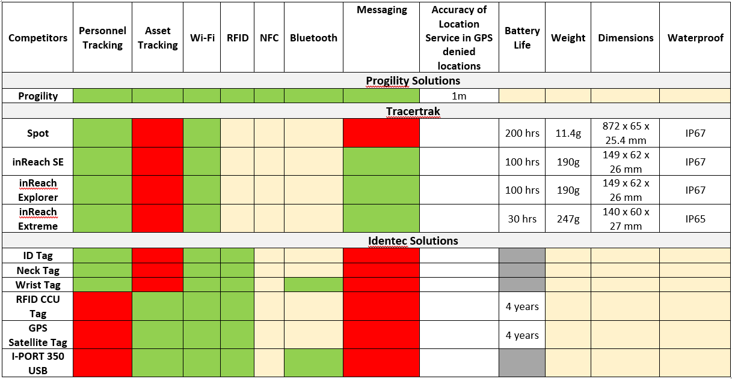

*Figure 2: A comparison of the features various tracking systems currently provide*

*- Function is available*

*- Function is not available*

*- Information unknown*

# 

# 5 Tracking Devices

There are many different types of sensor devices that can connect to wireless sensor networks. It is important to note that each of these devices are made to suit different working environments such as industrial environments and office environments. The technology on devices which are currently available on the market include:

* Wi-Fi
* RFID
* NFC
* Bluetooth
* GPS

Each specific device has its own specific environment that it would be useful in. For example, GPS Locators would not be useful to track personnel in mines or oil rigs as the employees will often be underground. Due to the harsh environment of an oil rig, some devices which are currently on the market are not feasible to use [8] [10].

## 5.1 Competitor Technological Capability Analysis

|  |  |  |  |
| --- | --- | --- | --- |
| **Competitor Technological Capability Analysis** | | | |
|  | **Progility Technologies** | **Identec Solutions** | **Tracertrak** |
| **Wi-Fi** | | | |
| **Description** |  |  |  |
| **Benefits** |  |  |  |
| **Value** |  |  |  |
| **Monetary Cost** |  |  |  |
| **RFID** | | | |
| **Description** |  |  |  |
| **Benefits** |  |  |  |
| **Value** |  |  |  |
| **Monetary Cost** |  |  |  |
| **NFC** | | | |
| **Description** |  |  |  |
| **Benefits** |  |  |  |
| **Value** |  |  |  |
| **Monetary Cost** |  |  |  |
| **Bluetooth** | | | |
| **Description** |  |  |  |
| **Benefits** |  |  |  |
| **Value** |  |  |  |
| **Monetary Cost** |  |  |  |
| **GPS** | | | |
| **Description** |  |  |  |
| **Benefits** |  |  |  |
| **Accuracy** |  |  |  |
| **Monetary Cost** |  |  |  |
| **Messaging** | | | |
| **Description** |  |  |  |
| **Benefits** |  |  |  |
| **Value** |  |  |  |
| **Monetary Cost** |  |  |  |
| **Battery Life** | | | |
| **Description** |  |  |  |
| **Benefits** |  |  |  |
| **Value** |  |  |  |
| **Monetary Cost** |  |  |  |
| **Weight** | | | |
| **Description** |  |  |  |
| **Benefits** |  |  |  |
| **Value** |  |  |  |
| **Monetary Cost** |  |  |  |
| **Dimensions** | | | |
| **Description** |  |  |  |
| **Benefits** |  |  |  |
| **Value** |  |  |  |
| **Monetary Cost** |  |  |  |
| **Waterproof** | | | |
| **Description** |  |  |  |
| **Benefits** |  |  |  |
| **Value** |  |  |  |
| **Monetary Cost** |  |  |  |

##### 

## **5.1.1** **Progility Technologies [14]**

· Provide Personnel and Asset Tracking

o Wifi systems

o RFID

o NFC

o Bluetooth

· Location based services in GPS denied locations

o CA-TAP system-accuracy of approximately 1m

o CA-TAP HD system-accuracy of approximately 55mm

· Underground mining and proximity detection

o Distance between two points through hard rock

o Custom alert system

### **5.1.2** **Tracertrak [11]**

#### **5.1.2.1** **Spot**

· Tracking

· Emergency Alerts

· Worker Check in

#### **5.1.2.2** **inReach SE**

* Tracking
* Emergency Alerts
* Worker Check in
* Send and receive message
* Message Delivery Confirmation

#### **5.1.2.3** **inReach Explorer**

* Tracking
* Emergency Alerts
* Worker Check in
* Send and receive message
* Message Delivery Confirmation
* Waypoint Saving

#### **5.1.2.4** **Iridium Extreme**

* Tracking
* Emergency Alerts
* Worker Check in
* Send and receive message
* eDelivery Confirmation
* Voice Communications

**5.1.3** **Identec Solutions [14]**

WATCHER**PERSONNEL** System:

· Personnel registration system

· Automated mustering system

· Mobile mustering

· Access control system

· Certification logging

· Integration with DaWinci personnel logistics system

· Custom reporting

· Active and passive monitoring

IDENTEC SOLUTION Mobile Mustering increases security and improves efficiency during an emergency through:

· Automated headcount per mustering zone

· Manual mustering of personnel without a tag

· Flexible lifeboat allocation

· Simple relocation of mustering points

· Real-time identification of missing personnel

Offline mode to mitigate network connectivity issues

|  |  |  |  |
| --- | --- | --- | --- |
| **Technology Capability Analysis Summary** | | | |
| **Technology Categories** | **Progility Technologies** | **Identec Solutions** | **Tracertrak** |
| Wi-Fi |  |  |  |
| RFID |  |  |  |
| NFC |  |  |  |
| Bluetooth |  |  |  |
| GPS |  |  |  |
|  |  |  |  |

# 

# 6 Scope for Innovation

By now it is clear that there already lots of solutions available on the market for personnel tracking. Each one has a number of configuration options and is specialized for a variety of environments. When attempting to deliver a solution to the market where the technology is not new, there are two options: implementing the existing solution into an new environment or adding functionality to the existing product.

It can be noted in the market analysis above that companies have not optimized their systems for use on an oil rig. The oil rig presents unique environmental challenges. Hence, one option for the team to pursue is to take a COTS product and harden it against exposure to salt water and sea spray.

Another key observation from the market analysis is that although most of the requirements desired by the client are covered by one system or another, there isn’t a single system that delivers exactly everything. In particular this is true of the water immersion sensor, as this is usually a totally separate solution and not bundled with the tracking system.

Ultimately, our prototype will seek to address both of these opportunities. The budget for the project does not allow for us to fully waterproof an existing solution, but we can experiment on a limited scale. We can also combine a water immersion sensor with a basic tracking system to highlight the advantage of bundling them together for an oil rig environment.

# 

# 7 Conclusion

Preliminary market research reveals that the market for tracking systems is well saturated with companies such as Wavetrend specializing in rugged tracking tags designed for construction and mining operations [13]. Many potential competitors already offer devices which work in a general setting, accommodating lots of room for review and specialization to suit the environment of an oil-rig better. However, there appeared to be less saturation for a system specialized for use in an oil rig, so the focus was shifted from a general system to one optimized for that environment. Since the development of a completely new system may not be the most efficient way of moving- forward, two ways of potential action with the project were concluded:

1. Implementing existing solution into new environment
2. Adding functionality to existing product

Hence, the team recommends that the client develop a system where:

As a result, the team recommends a waterproof and failsafe device that sends real time location to a central system via RF wireless transmission. Furthermore, the device will be able to detect salinity level for accidental personnel submersion, be able to detect fatigue levels of personnel and be able to alert personnel of any emergency notification. Finally, the device will be able to perform all the aforementioned tasks while lasting a full day of work.

# **8 References**

[1] R. FLIN, G. SLAVEN and K. STEWART, "Emergency Decision Making in the Offshore Oil and Gas Industry", *Human Factors: The Journal of the Human Factors and Ergonomics Society*, vol. 38, no. 2, pp. 262-277, 1996.

[2] J. Barab, "Worker Safety in our Nation's Energy Production Industries | Occupational Safety and Health Administration", *Osha.gov*, 2018. [Online]. Available: https://www.osha.gov/news/testimonies/06102012. [Accessed: 26- Mar- 2018].

[3] J. Skogdalen, I. Utne and J. Vinnem, "Developing safety indicators for preventing offshore oil and gas deepwater drilling blowouts", *Safety Science*, vol. 49, no. 8-9, pp. 1187-1199, 2011.

[4] A. Ene, "How Technology Is Changing The Oil And Gas Landscape - For The Better", *Smart-grid.energycioinsights.com*, 2018. [Online]. Available: https://smart-grid.energycioinsights.com/cxo-insights/how-technology-is-changing-the-oil-and-gas-landscape-for-the-better-nwid-51.html. [Accessed: 26- Mar- 2018].

[5] N. Ramzali, M. Lavasani and J. Ghodousi, "Safety barriers analysis of offshore drilling system by employing Fuzzy Event Tree Analysis", *Safety Science*, vol. 78, pp. 49-59, 2015.

[6] G. Mathisen and L. Bergh, "Action errors and rule violations at offshore oil rigs: The role of engagement, emotional exhaustion and health complaints", *Safety Science*, vol. 85, pp. 130-138, 2016.

[7] R. Gardner, "Overview and Characteristics of Some Occupational Exposures and Health Risks on Offshore Oil and Gas Installations", *The Annals of Occupational Hygiene*, vol. 47, no. 3, 2003.

[8] "Wearable Devices Used for Employee Location Tracking | Wearables List | Vandrico Inc", *Vandrico.com*, 2018. [Online]. Available: https://vandrico.com/wearables/device-categories/workplace-applications/employee-location-tracking. [Accessed: 26- Mar- 2018].

[9] "Home | progility.com.au", *Progility.com.au*, 2018. [Online]. Available: http://www.progility.com.au/. [Accessed: 26- Mar- 2018].

[10] J. Shoemaker, "When Does Tracking Workers Make Sense? - 2014-10-05 - Page 1 - RFID Journal", *Rfidjournal.com*, 2018. [Online]. Available: http://www.rfidjournal.com/articles/view?12274. [Accessed: 26- Mar- 2018].

[11] "LONE WORKER SAFETY AND SATELLITE COMMUNICATIONS", *Tracertrak.com.au*, 2018. [Online]. Available: http://www.tracertrak.com.au/wp-content/uploads/sites/2/2016/07/Tracertrak-AU-Lone-Worker-07072016.pdf. [Accessed: 26- Mar- 2018].

[12] "Products | Emerald Marine Products", *Emeraldmarineproducts.com*, 2018. [Online]. Available: http://emeraldmarineproducts.com/products/. [Accessed: 26- Mar- 2018].

[13] E. Web, "Activ Tags | Wavetrend", *Wavetrend.net*, 2018. [Online]. Available: http://www.wavetrend.net/activ-tags.php. [Accessed: 27- Mar- 2018].

# 9 Appendix

## 9.1 House of Quality

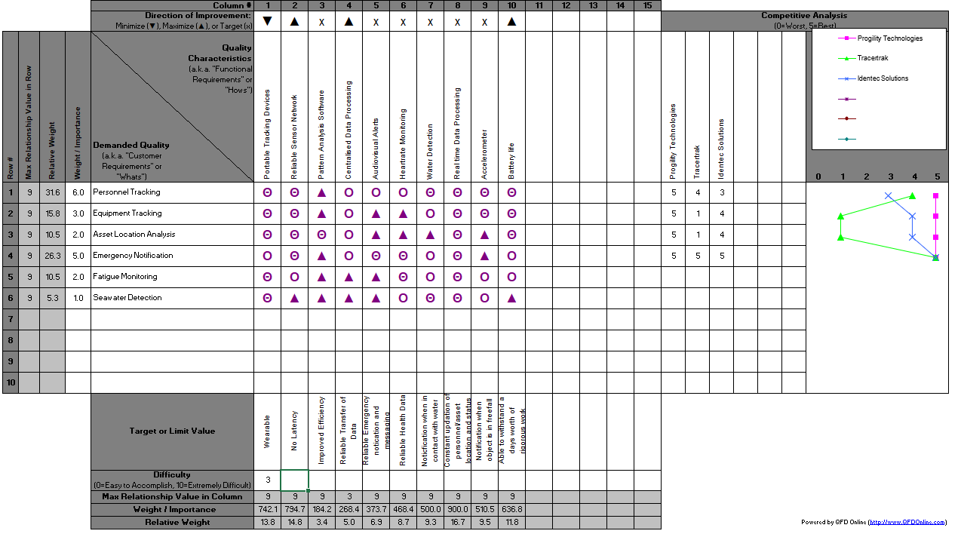

## **9.2 Pairwise Analysis**

|  |  |  |  |  |  |  |  |  |
| --- | --- | --- | --- | --- | --- | --- | --- | --- |
|  | Personnel Tracking | Equipment Tracking | Asset Location Analysis | Emergency Notification | Fatigue Monitoring | Seawater Detection | Sum | Rank |
| Personnel Tracking |  | 1 | 1 | 1 | 1 | 1 | 5 | 1 |
| Equipment Tracking | 0 |  | 1 | 0 | 1 | 1 | 3 | 3 |
| Asset Location Analysis | 0 | 0 |  | 0 | 0 | 1 | 1 | 5 |
| Emergency Notification | 0 | 1 | 1 |  | 1 | 1 | 4 | 2 |
| Fatigue Monitoring | 0 | 0 | 1 | 0 |  | 1 | 2 | 4 |
| Seawater Detection | 0 | 0 | 0 | 0 | 0 |  | 0 | 6 |

*Figure 1: A pairwise analysis of the tracking system’s features*